

Radar Jamming using Adalm pluto SDR

Internship Report

Submitted to : Dr Hammad Cheema
Submitted by: Museera Itlish

Table of content

- Introduction ………………………………………………………………………………………..3

- Theoretical Background……………………………………………………………………………3

- Signal transmission path(Pluto SDR Transmitter)……………………………………………3

- Signal Reception Path(Pluto SDR Receiving)………………………………………………...4

- Practical Setup of SDR………………………………………………………………………..5

- Jamming Methodology …………………………………………………………………………...9

- WiFi Hotspot jamming……………………………………………………………..9

- WiFi Home Network Jamming……………………………………………………..9

- Pulsed Jamming…………………………………………………………………….10

- Noise Signal Generation……………………………………………………………13

- Comparative Analysis of jamming Techniques…………………………………….18

- Conclusion ………………………………………………………………………………………..25

Introduction
Radar jamming involves transmitting signals to disrupt radar operation and is a core technique in electronic warfare. This work explores several jamming methods—wideband noise, sweep, spot, pseudo-noise, and pulsed jamming—using the ADALM-Pluto SDR and MATLAB.
The process included theoretical study, signal generation, and real-time experiments on frequencies like 915 MHz and 2.4 GHz. Key metrics such as J/S ratio, burn-through range, power control, and duty cycle were used to assess performance. This report presents the methodology and results of each jamming approach.
All experiments in this project were conducted using the ADALM-Pluto SDR in controlled and safe environments.The transmissions were restricted to low-power, short-range operation . Care was taken to ensure that no harmful interference occurred to external systems. The work was performed solely for academic and educational purposes as part of the internship.

Theoretical Background
Electronic jamming is a key aspect of electronic warfare, aimed at disrupting enemy radar and communication systems by transmitting interfering signals. Radar jamming specifically targets the radar’s ability to detect, track, or identify targets by corrupting the reception and interpretation of its own echoes.
This project focused on understanding and testing jamming techniques using the ADALM-Pluto Software Defined Radio (SDR) in a controlled lab environment. Radar systems operate by transmitting electromagnetic waves and analyzing reflected signals to determine target parameters like range and velocity. Jamming disrupts this process .

Signal Transmission Path (Pluto SDR Transmitter)

1. Signal Generation (Baseband):
- A baseband waveform (e.g., noise, pulse, chirp) is generated using MATLAB or GNU Radio.
- This signal exists as a sequence of complex I/Q samples.

2. Digital-to-Analog Conversion (DAC):
- The I/Q samples are sent to the Pluto SDR’s internal DAC.
- Converts the digital baseband signal into an analog baseband waveform.

3. Frequency Upconversion (Mixer + LO):
- The analog baseband signal is mixed with a local oscillator (LO) to shift it to the desired RF center frequency (e.g., 915 MHz, 2.4 GHz).
- This creates the RF signal centered at the selected transmission frequency.

4. RF Amplification:
- The upconverted RF signal is optionally amplified internally within the SDR for transmission.

5. Transmission via Antenna:
- The RF signal is transmitted wirelessly through the SDR's TX antenna.
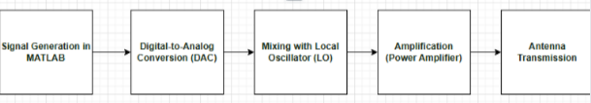
- Signal Reception Path (Pluto SDR Receiver)

1. RF Signal Capture (Antenna):
- The SDR’s RX antenna captures incoming electromagnetic signals from the environment (including jamming signals or radar pulses).

2. RF Downconversion (Mixer + LO):
- The captured RF signal is mixed down with the LO to produce an analog baseband signal centered around 0 Hz.

3. Analog Filtering:
- A low-pass filter removes out-of-band components, isolating the desired baseband signal.

4. Analog-to-Digital Conversion (ADC):
- The filtered analog baseband is digitized into complex I/Q samples by the SDR’s ADC.

5. Sample Transfer to Host (USB):
- The digitized I/Q samples are sent to the host computer via USB.

6. Signal Processing (MATLAB/GNU Radio):
- The received samples are analyzed in software for time-domain, frequency-domain, or statistical characteristics (e.g., J/S ratio, spectrum).
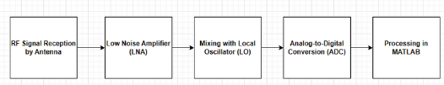

Practical Setup of the SDR:
To perform the experiments, the ADALM-Pluto SDR was configured and operated through MATLAB with the Communications Toolbox Support Package. The setup process was carried out as follows:
- Device Connection
The SDR was connected to the host computer via USB. MATLAB automatically detected the hardware once the support package was installed. Device parameters such as IP address and serial number were confirmed using built-in diagnostic commands.
- Transmitter Configuration
The transmitting SDR was assigned the center frequency (e.g., 915 MHz or 2.4 GHz), sampling rate, transmit gain, and baseband signal type. MATLAB scripts generated waveforms such as Gaussian noise, pseudo-noise, or chirps, which were streamed to the SDR’s DAC for over-the-air transmission.
- Receiver Configuration
The receiving SDR was tuned to the same center frequency and sampling rate as the transmitter. Receive gain was adjusted to avoid saturation while ensuring a clear capture of signals. Incoming I/Q samples were continuously streamed to MATLAB for real-time analysis.
- Antenna Setup
Suitable antennas were connected to the TX and RX ports. For Wi-Fi band experiments, 2.4 GHz antennas were used, while ISM band experiments at 915 MHz used matched antennas. Antennas were positioned a few feet apart in a controlled indoor lab environment.
- Signal Transmission and Capture
MATLAB scripts were executed to initiate both transmission and reception. The transmitter sent the generated waveform, while the receiver captured and stored the signal for visualization. Time-domain plots, FFT spectrums, and power measurements were used to verify correct operation.
- Experimental Validation
Each jamming method (wideband noise, sweep, spot, pulsed, PN) was tested by observing its effect on either a communication link (Wi-Fi) or a radar-like pulsed signal. Jamming performance was validated through measurements of J/S ratio, duty cycle, and power control.
This systematic setup ensured repeatable experiments, allowing both theoretical and practical aspects of jamming to be analyzed using the same SDR platform.

- Noise jamming aims to raise the noise floor at the radar receiver by transmitting continuous or pulsed energy, making it difficult or impossible to distinguish real target returns. This technique is further divided into several types:
- Spot jamming
- Spot jamming focuses all jamming power on a single frequency.
- Effective only against radars using fixed frequencies.
- Easily countered by frequency or pulse agility.
- Implemented by transmitting a single-tone signal near the radar-like center frequency.
- Used ADALM-Pluto to visualize how narrowband jamming can mask a specific band.
- Sweep jamming
- Sweep jamming modifies spot jamming by sweeping across a range of frequencies rapidly.
- Covers multiple frequencies in succession, but not simultaneously.
- Implemented using frequency-modulated chirps, sometimes mixed with random noise for unpredictability.
- Effective against frequency-hopping or agile radars that change frequencies rapidly.
- Barrage jamming
- Barrage jamming is a wideband jamming technique.
- Transmits noise simultaneously across a broad frequency range.
- Unlike sweep jamming, it covers all frequencies at once instead of cycling through them.
- Spreading power over a wide bandwidth reduces power density per frequency.
- Less effective against strong radar signals or systems with narrow filters.
- Pulse jamming
- Pulse jamming uses intermittent noise bursts to disrupt radar pulses.
- Pulses can be synchronized with radar’s PRI or sent at random intervals.
- Conserves power and makes the jammer harder to detect.
- In this internship, randomized Gaussian noise pulses were used.
- Pulse width and duty cycle were adjustable for testing different jamming effects.
- PN Jamming
- PN jamming uses deterministic, noise-like sequences (e.g., BPSK-modulated m-sequences).
- Offers advantages like repeatability and a controlled spectrum.
- Implemented in MATLAB and transmitted using ADALM-Pluto SDR.
- Used to study how structured noise compares with random noise in jamming scenarios.
- Digital Radio Frequency Memory (DRFM)
Beyond noise jamming, deceptive jamming involves capturing radar signals and retransmitting modified versions to mislead the radar. A key method is Digital Radio Frequency Memory (DRFM), which samples incoming pulses, applies delays or frequency shifts, and replays them to create false targets. Although DRFM was not implemented in this internship, its theoretical understanding was essential to grasp modern jamming strategies.
E. Jamming effectiveness metrics:
Jamming-to-Signal (J/S) ratio
To evaluate jamming effectiveness, one of the key metrics used is the Jamming-to-Signal (J/S) ratio. This ratio compares the power of the jamming signal received at the radar to that of the target echo. A higher J/S ratio implies more effective jamming. It can be influenced by several factors, including the transmitted power of both radar and jammer, antenna gains, distance (R), target radar cross-section (σ), and bandwidths of both radar and jamming signals. The generalized expression is:
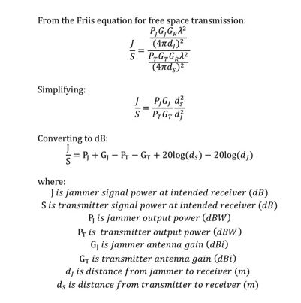
Burn-through range
Another important concept is the burn-through range, which is the distance at which the radar signal becomes strong enough to overcome the jamming signal due to inverse square law attenuation. Inside this range, radar can detect targets despite jamming. .
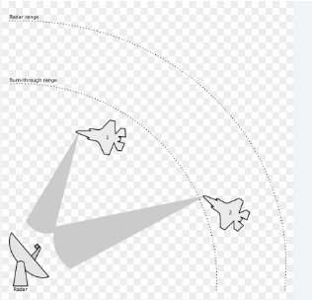

Duty cycle and power control:
Duty cycle and power control are critical aspects of jammer design. The duty cycle defines how much of the time the jammer is actively transmitting within a given interval. A lower duty cycle conserves energy and reduces detectability, while a higher one increases interference. Power control, including adjusting transmission amplitude and gain, directly affects the strength and coverage of the jamming signal. Both were explored experimentally by observing changes in pulse visibility and signal interference as these parameters were varied

F.RADAR BASICS:
Working principle of radar:
RADAR transmits radio waves, receives echoes from objects, and uses signal processing to detect and locate targets.

Advantages of RADAR:
- All-Weather Capability — Operates in rain, fog, and dust
- Day & Night Operation — Functions regardless of lighting Long-Range Detection — Can detect distant objects
- Multi-Target Tracking — Tracks several objects at once

The Radar Range Equation describes how the power of a radar signal decreases as it travels to a target and back, and how much of that signal can be detected by the receiver. It depends on:
- Transmitted Power (Ps)
- Antenna Gain (G)
- Radar Cross Section (σ) – how well the target reflects energy
- Wavelength (λ)
- Range (R) – distance to the target
- System Losses (L)
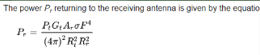The received power decreases with the fourth power of distance (1/R⁴) due to the two-way propagation.

- Jamming methodology:

Wi-Fi Hotspot Jamming
To evaluate the practical impact of jamming, a mobile phone hotspot operating on Channel 1 (2.412 GHz) in the 2.4 GHz ISM band was selected as the target. Wideband Gaussian noise was generated in MATLAB and transmitted over the air using the ADALM-Pluto SDR to cover the hotspot’s frequency range. The SDR was positioned in close proximity to the hotspot, and the transmit gain was adjusted to achieve effective interference.
As a result, the internet connection on a nearby device became unstable and was eventually disconnected. This confirmed that wideband noise transmission could successfully disrupt real Wi-Fi communication, providing a basic proof-of-concept for subsequent jamming experiments.

Wi-Fi Home Network Jamming

Experiment
In this experiment, a home Wi-Fi router operating within the 2.4 GHz ISM band was selected as the target, specifically on Channel 8 at approximately 2.447 GHz. The objective was to evaluate the effectiveness of a continuous noise signal in disrupting a stable wireless network under real-world conditions.
Wideband Gaussian noise was generated in MATLAB and transmitted using the ADALM-Pluto SDR, centered around the target frequency range. This type of noise was chosen for its broadband interference properties, which are particularly suitable for masking Wi-Fi signals that typically occupy 20–22 MHz of bandwidth per channel. The SDR’s transmission power and gain were carefully adjusted to provide adequate signal strength within the jamming zone.
During testing, both a laptop and a mobile phone were connected to the home Wi-Fi network. Once the Gaussian noise transmission commenced, both devices exhibited connectivity issues. For documentation purposes, only the laptop’s behavior was recorded on video as evidence of the jamming effect.

Results
The recorded video clearly demonstrated the loss of network connectivity immediately after the jammer was activated. Once the transmission was stopped, the laptop’s connection was promptly restored, and normal browsing activity resumed. This on–off behavior provided direct evidence of the cause-and-effect relationship between the jamming signal and the disruption of Wi-Fi communication.
The experiment confirmed that continuous noise jamming in the 2.4 GHz band can effectively interfere with Wi-Fi connectivity from a home router. It further highlighted that the impact of jamming is frequency-selective and power-dependent, showing that even relatively low-power wideband noise is capable of disabling common communication systems within a localized area.

Pulsed signal jamming

Experiment
In this experiment, a pulse-modulated signal was transmitted using an ADALM-Pluto SDR to emulate a radar-like waveform. Although the signal did not include range-gating or Doppler processing, it exhibited clear time-domain pulsing behavior — short bursts of sinusoidal energy repeated at regular intervals — making it a suitable testbed for evaluating pulse jamming techniques.
To interfere with this pulsed signal, a second ADALM-Pluto SDR was employed, running a custom MATLAB script (pulse_jamming_noise.m) that generated Gaussian noise pulses with random start times within each transmission frame. These noise pulses were complex-valued, wideband, and of configurable duration, effectively serving as randomized barrage jamming. The objective was to create random temporal overlaps between the noise pulses and the pulsed signal, thereby corrupting the periodic structure of the original waveform.
Results
At the receiver, the captured waveform revealed clear evidence of jamming. In the time domain, the originally clean pulse train became disrupted — in many frames, noise pulses coincided with signal pulses, resulting in a distorted or masked waveform. This confirmed the effectiveness of the interference.
The Jamming-to-Signal (J/S) ratio was also measured by recording the power of the reference pulse without jamming and comparing it with the overlapping signal once jamming was activated. Expressed in decibels, the J/S ratio quantified the degree to which the jamming signal overpowered the original waveform. These measurements provided insight into how pulse overlap, power control, and duty cycle influence the effectiveness of time-coincident noise jamming.
Overall, the experiment demonstrated that even without precise synchronization, randomized pulsed noise can significantly degrade the clarity of pulse-based signals, achieving one of the key objectives of radar jamming and deception.
Before sending noise
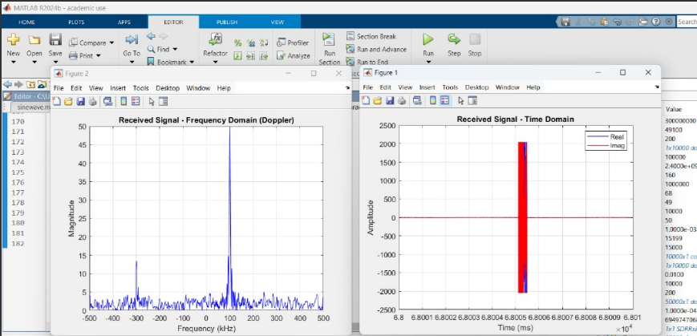
After sending noise:

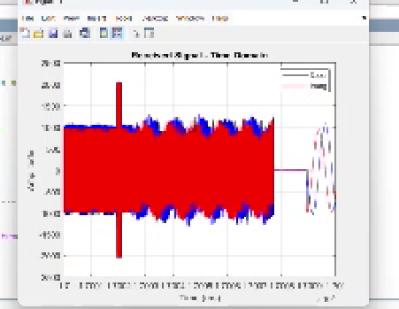
J/S ratio:
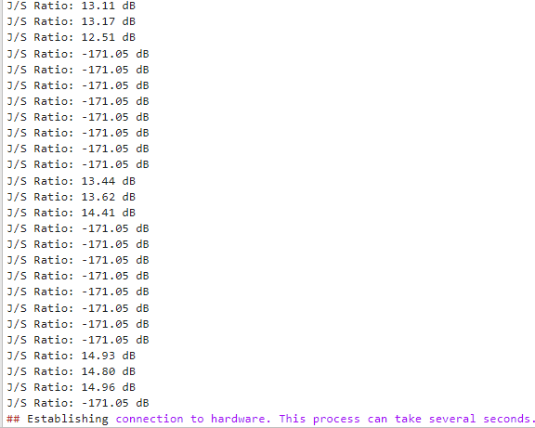
- J/S = -171 dB when:
  - Noise pulse does not overlap with the radar pulse.
  - Jamming power during the pulse window is almost zero.
  - MATLAB logs a very low ratio due to near-zero jamming power.
- J/S = Positive (e.g., 13–15 dB) when:
  - Noise does overlap with the radar pulse.
  - Jamming power is significant during the pulse window.
  - Indicates effective jamming of the pulse signal.
Why -171 dB
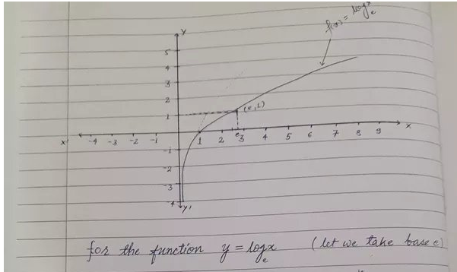
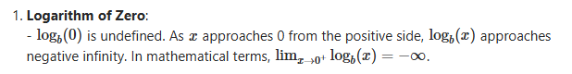MATLAB/Computer Limitation:
- In practice, logarithms of zero can't be calculated, so MATLAB or our script sets a lower bound (floor value). That floor value is -171.05 dB — a default minimum due to:
- Floating-point precision limits (usually ~1e-17 to 1e-18)
- A small constant added to avoid log(0), like:
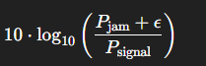
So we're seeing -171 dB not because that's the "real" J/S ratio, but because it's the lowest representable value in your code or system when jamming power is essentially zero.

Noise Signal Generation and Visualization (Gaussian, PN, Sweep, Spot)
In addition to the targeted jamming experiments, various noise signals were explored and transmitted—each representing a different jamming technique or signal structure.These were not used to jam specific signals but rather to study their spectral properties, visualize their behavior, and understand their potential for different jamming scenarios.
- Gaussian noise:
The Gaussian noise script continuously transmitted complex Gaussian samples over the air using the ADALM-Pluto SDR. This served as a model for wideband barrage noise jamming, where the goal is to overwhelm a broad range of frequencies. The transmitted signal appeared as a flat spectrum in the frequency domain, confirming that energy was spread across the entire occupied bandwidth. This kind of jamming is useful when the exact frequency of the target signal is unknown or when multiple channels need to be saturated simultaneously.
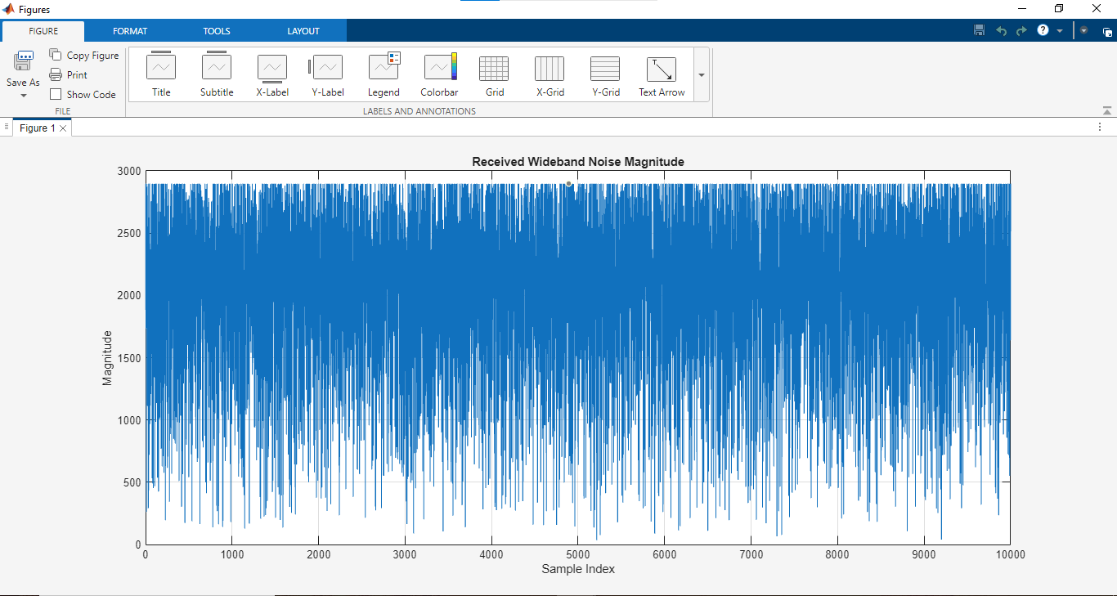
- Pseudo-Noise:
The Pseudo-Noise (PN) sequence was generated using a BPSK-modulated maximal length sequence (m-sequence). The resulting signal appeared noise-like in time but exhibited sharp spectral peaks due to the periodicity of the PN pattern. This kind of signal can be used in repeater jamming or code-based deception, and is also relevant in systems where jammers aim to mimic or confuse spread-spectrum receivers. The experiment helped in understanding how structured noise behaves differently from purely random noise.
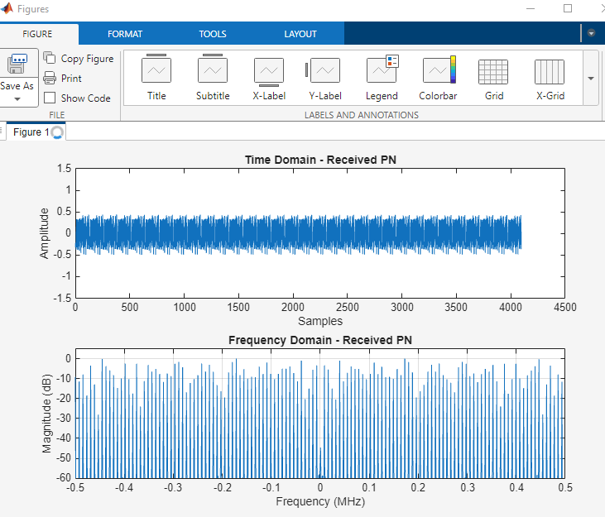
- Sweep Noise Signal
The sweep noise signal was implemented as a linear frequency-modulated (LFM) chirp that swept across a chosen bandwidth in time. In MATLAB, this was constructed using a chirp function and optionally mixed with Gaussian noise to add randomness. The sweep was repeated continuously and visualized both in time and frequency domains. This kind of swept jamming is particularly relevant against frequency-hopping systems or radar signals whose carrier varies with time. The frequency-domain visualization clearly showed energy sweeping across the band, confirming correct transmission.

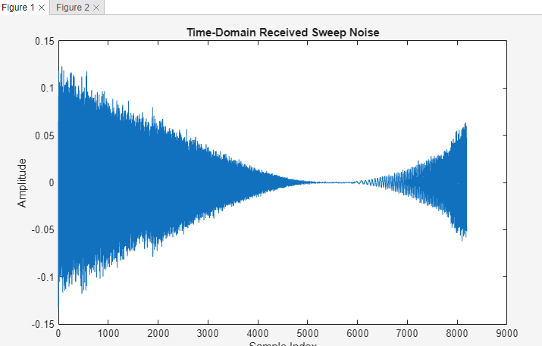
- Spot Jamming Noise:
Lastly, spot jamming was tested by transmitting a single-tone sine wave offset by 1 MHz from the center frequency (2.4 GHz). This kind of jamming is useful for targeted disruption of narrowband communications like Wi-Fi channels, GPS signals, or specific subcarriers in OFDM systems. In the frequency domain, the spot jammer appeared as a narrow spike at the intended frequency, confirming its focused nature.
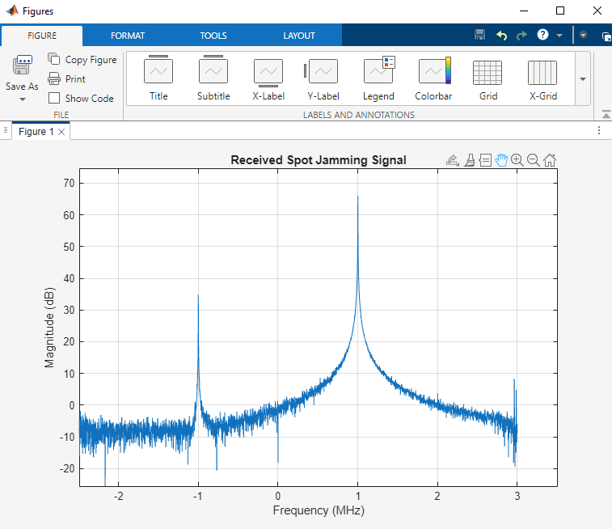
Each of these signal types was received and visualized in real-time using the Pluto SDR receiver,allowing comparison of their spectral characteristics, assessment of their power distributions, and deeper understanding of their theoretical and practical implications
- Pulsed Noise:
Pulsed noise jamming transmits short bursts of noise at intervals to disrupt radar pulses while conserving power and reducing detectability. In this project, randomized Gaussian noise pulses were generated using MATLAB and transmitted via ADALM-Pluto SDR, with tunable pulse width and duty cycle to study their impact.
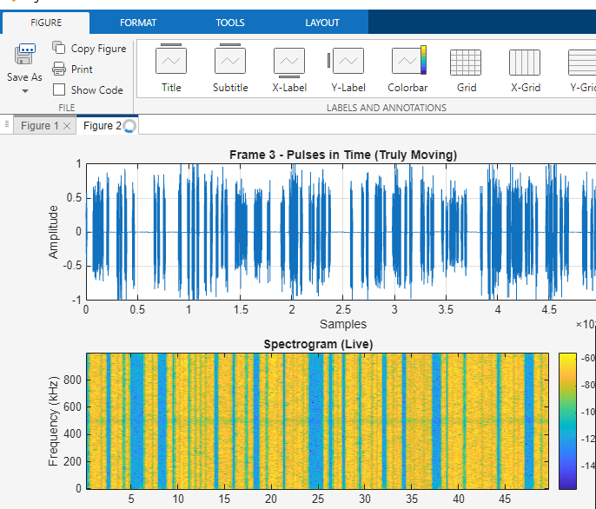

- Comparative Analysis of Jamming Techniques

Method | Type | Bandwidth | Targeting | Key Advantage | Typical Use Case
Gaussian Noise | Wideband noise | Very wide (flat spectrum) | Non-selective (entire band) | High interference across full band | General wireless jamming
Pseudo-Noise | Structured wide noise | Wide | Non-selective, repeatable | Deterministic, useful in spoofing | Signal imitation, analysis
Pulsed Noise | Time-limited noise | Wide (in pulses) | Time-selective (pulse overlap) | Energy-efficient, radar pulse disruption | Pulsed radar jamming
Sweep Noise | Frequency-varying | Narrow at each time | Frequency-scanned interference | Covers full band over time | Anti-frequency-agile radars
Spot Noise | Single-tone | Narrowband (~1 Hz–kHz) | Highly frequency-selective | Efficient for targeted jamming | Specific channel or signal jamming

Practical Usage Notes
- Gaussian noise is easiest to implement but consumes the most power.
- Pulsed noise was the most effective for radar-like systems, especially when aligned with signal pulses.
- Sweep noise provided a dynamic visual in spectrograms and can be adapted to jam agile systems.
- Pseudo-noise was deterministic and can be used in future spoofing experiments.
- Spot noise was useful for observing targeted spectral interference.

- Over-the-Air Jamming Using VSG and Horn Antenna
After completing the Pluto-to-Pluto laboratory experiments, additional over-the-air tests were performed using a Vector Signal Generator (VSG) to generate target signals and a horn antenna to transmit them. This setup was designed to more closely replicate practical jamming scenarios beyond loopback or SDR-only testing.
The VSG was configured to transmit both continuous wave (CW) and pulse-modulated signals at 2.4 GHz and 3.5 GHz. Initially, experiments were conducted in the 2.4 GHz ISM band; however, due to overlap with Wi-Fi channels and potential interference with surrounding networks, the experiments were later shifted to 3.5 GHz for safety and reliability.
Jamming was performed using the ADALM-Pluto SDR, which transmitted either spot noise or wideband Gaussian noise generated in GNU Radio. The SDR’s gain and transmission power were adjusted to ensure effective interference.
The test arrangement involved two laptops:
- One laptop controlled the Pluto SDR to generate and transmit the jamming noise.
- The second laptop acted as the receiver, capturing both the clean signal and the jammed signal for analysis.
To study the spatial effect of jamming, the jammer was gradually moved farther from the VSG–receiver link. The results confirmed that jamming effectiveness decreased with distance, illustrating the role of signal power and propagation loss in practical interference scenarios.
This experimental phase validated that spot noise could selectively mask narrowband signals, while wideband Gaussian noise was effective in disrupting both continuous and pulsed transmissions across a broader frequency range.
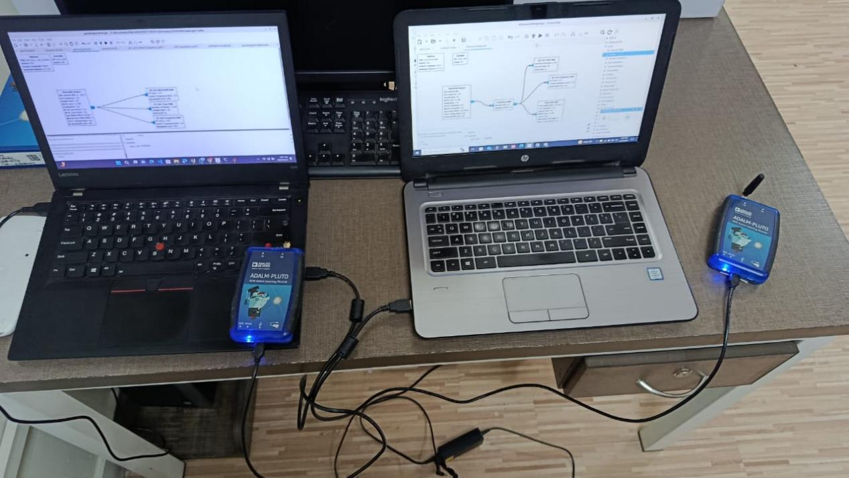

Spot Noise Jamming
Spot noise jamming was implemented by transmitting a narrowband tone close to the frequency of the target signal. When the jammer was placed near the transmitter–receiver link, the effect was immediately visible: the target waveform became masked by the strong interfering tone, and the received spectrum showed a clear spike overpowering the desired signal. This demonstrated how even low-power spot jamming can effectively deny communication when positioned in close proximity.
As the jammer was moved farther away, the interference effect weakened due to propagation loss. In the spectrum plots and time-domain captures, the jamming tone became less dominant, and the target signal gradually reappeared. These results confirmed the range-limited nature of spot noise jamming — highly effective at close range but less so as distance increase
GNU Radio blocks for Spot noise:
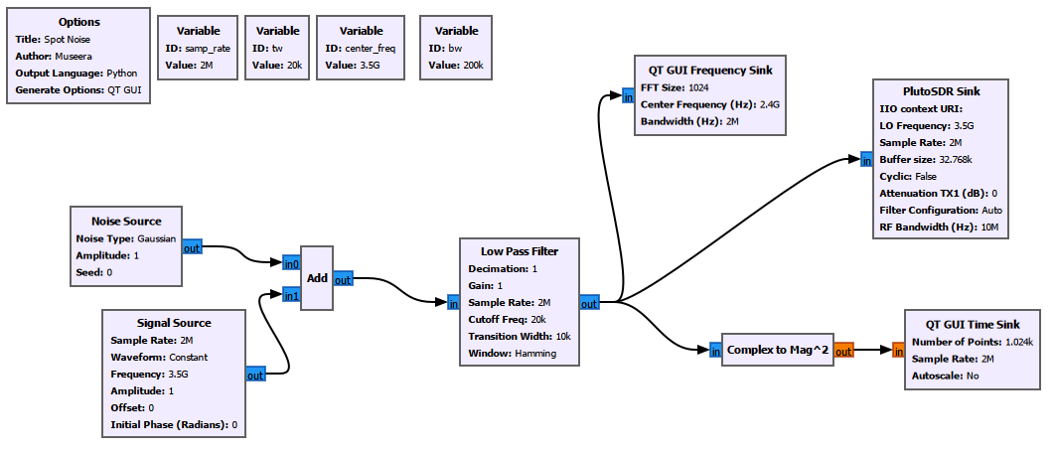

When two SDRs were few centimeter apart :
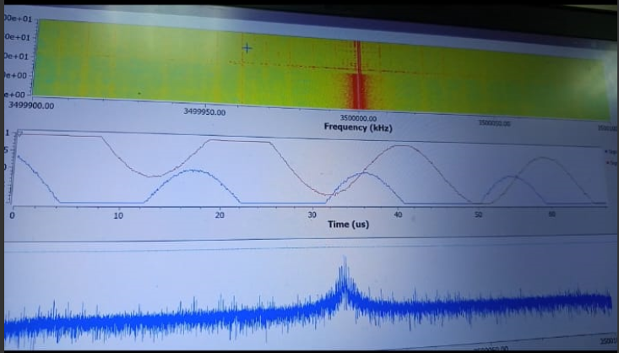
When the SDRs were really close:
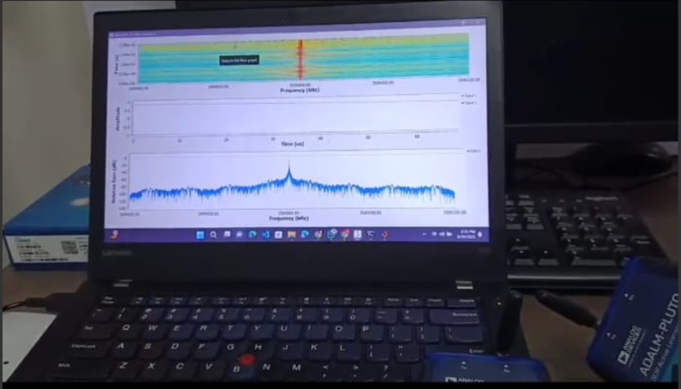

When SDRs were aroud 8 feets apart:
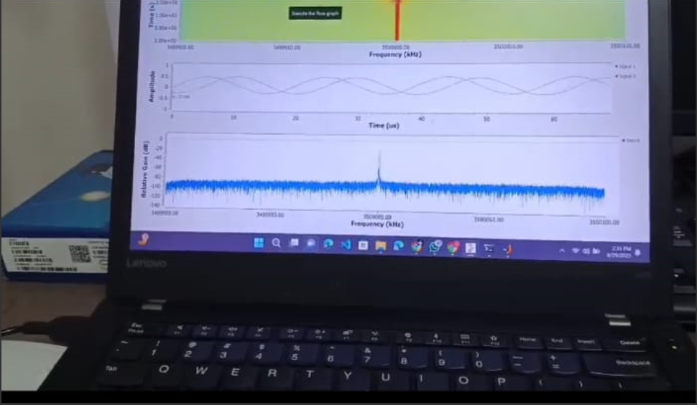

Wideband Noise Jamming
Wideband noise jamming was performed using Gaussian noise spread across the frequency band of interest. Unlike spot noise, this method did not produce a single spike but instead elevated the noise floor across a wide frequency range, effectively drowning out both continuous and pulsed signals. When the jammer was placed close to the target system, the received waveform became almost completely corrupted, with the original signal no longer distinguishable in either the time or frequency domains.
At greater distances, the jamming effect was still present but less pronounced. The elevated noise floor began to drop as the jammer moved farther away, allowing portions of the target signal to re-emerge. Nonetheless, wideband noise remained disruptive over a larger area compared to spot noise, confirming its effectiveness for general-purpose denial of service.

GNU Radio blocks for Wideband noise: 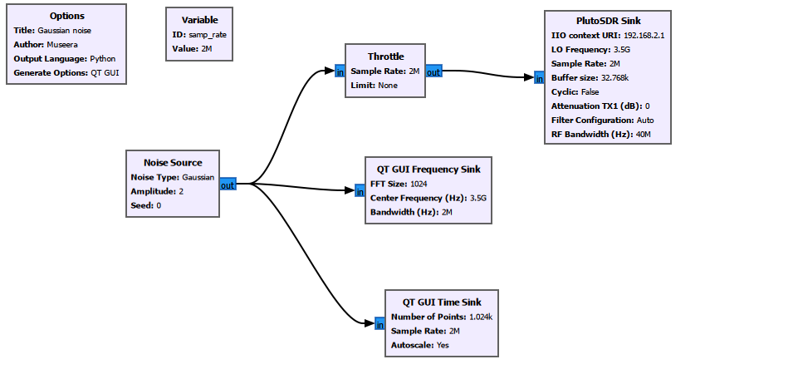

SETUP: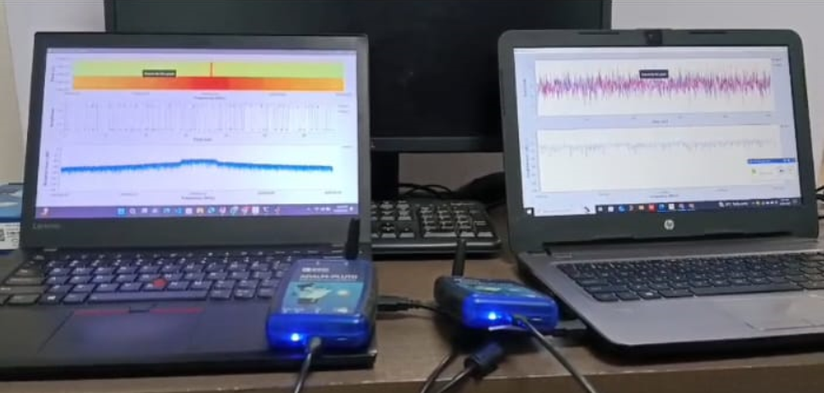
When SDRs were really close:
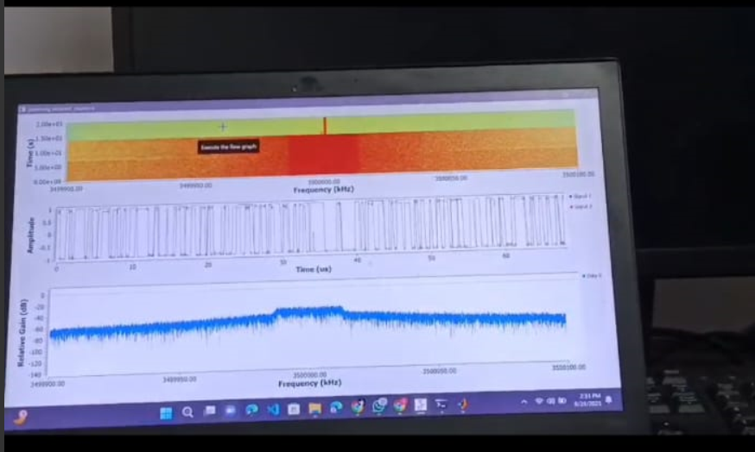
When SDRs were around 1 feet apart :
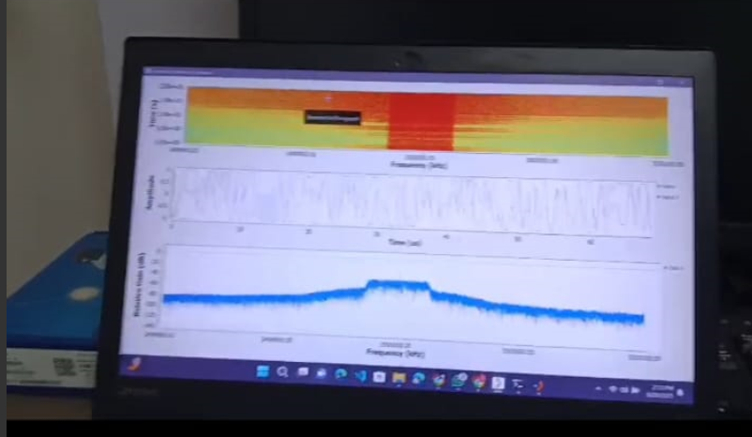
SDRs were 10 feet apart:
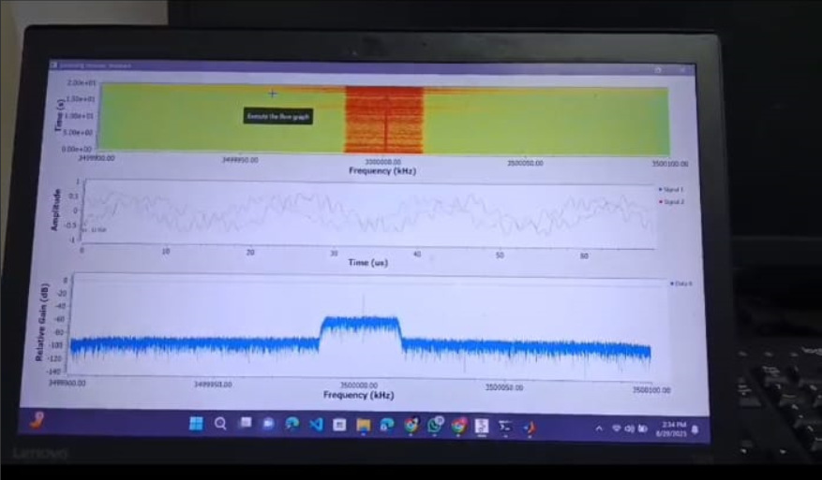
When 13 feet apart : 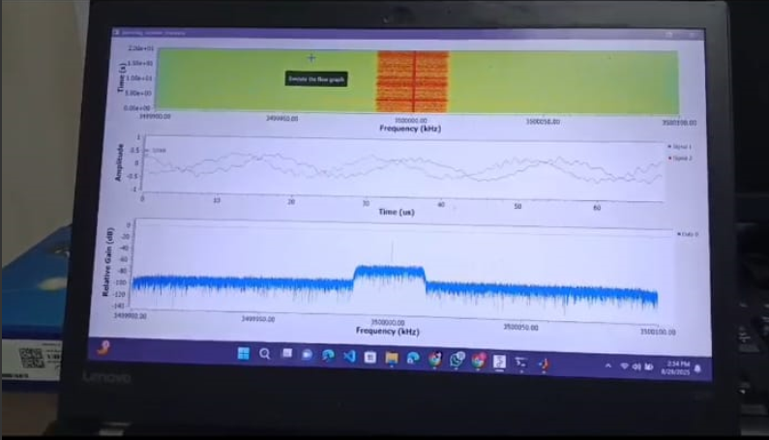

Conclusion
This internship provided valuable hands-on experience in implementing and analyzing radar jamming techniques using ADALM-Pluto SDR. Through theoretical exploration and practical experiments, the internship provided a deep understanding of different jamming methods, signal behavior, and performance metrics like the J/S ratio. The project strengthened skills in signal processing and SDR programming, while also demonstrating the real-world impact and challenges of electronic warfare systems

References:
- https://wiki.analog.com/university/tools/pluto
- https://www.ll.mit.edu/sites/default/files/outreach/doc/2018-07/lecture%202.pdf
- https://github.com/timkim0713/RFJamming-FMRadio-SDR
- https://github.com/tiiuae/jamrf
- https://www.researchgate.net/publication/301850218_Software_Defined_Radio_for_Wi-Fi_Jamming
- https://www.youtube.com/watch?v=B0036XWCacU
- https://scispace.com/pdf/wi-fi-jamming-using-software-defined-radio-4czsiyb2yk.pdf

